create TABLE employ(

EM_id int PRIMARY KEY AUTO_INCREMENT,

FM varchar(50),

LM varchar(50),

Salary int,

join_date TIMESTAMP DEFAULT CURRENT_TIMESTAMP,

department varchar(50)

)

INSERT into employe(FM,LM,Salary,department) VALUES("JOHN","ABRAHAM",1000000,"BANKING"),

("MICHAEL","CLERK",80000,"INSURANCE"),

("ROY","THOMAS",70000,"BANKING"),

("TOP","JONES",60000,"INSURANCE"),

("JERRY","PINTO",65000,"INSURANCE"),

("PHILIP","MATHEW",75000,"SERVICE")

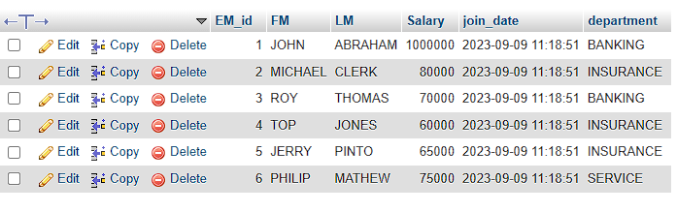

create TABLE incintiv(

IN_id int PRIMARY key AUTO_INCREMENT,

EM_REF_id int,

FOREIGN KEY(EM_REF_id) REFERENCES employ(EM_id),

incentiv_date TIMESTAMP DEFAULT CURRENT_TIMESTAMP,

incentiv_AMT int

)

INSERT into incintiv(incentiv_AMT) VALUES(5000),(3000),(4000),(4500),(3500)

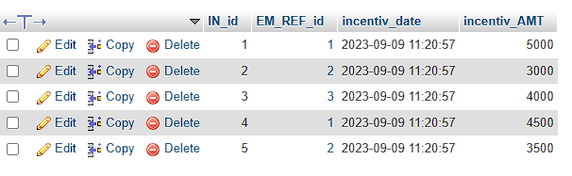

( A ) answer = SELECT FM as AlisName FROM employe

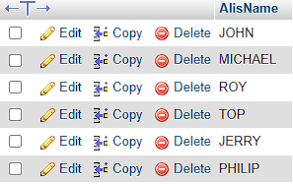

( B ) answer = SELECT FM, EXTRACT(YEAR FROM join_date) AS year,

EXTRACT(MONTH FROM join_date) AS month,

EXTRACT(day FROM join_date) AS day FROM employe

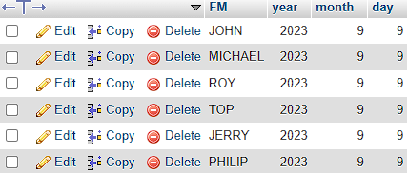

( C ) answer = SELECT FM,Salary FROM employe ORDER BY FM ASC, Salary DESC;

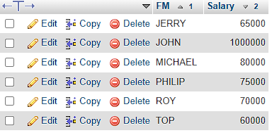

( D ) answer = SELECT FM FROM employe WHERE FM LIKE "%o%"

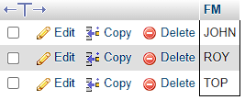

( E ) answer = SELECT * from employe WHERE MONTH(join_date) = 9;

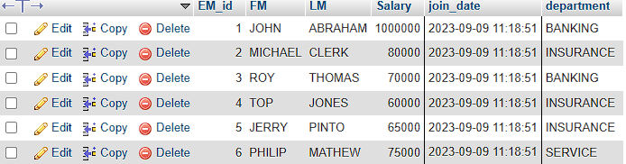

( F ) answer = SELECT department , sum(Salary) FROM employe GROUP BY department ORDER BY Salary DESC;

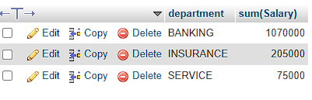

( G ) answer = SELECT department , MAX(Salary) FROM employe GROUP BY department ORDER BY Salary ASC;

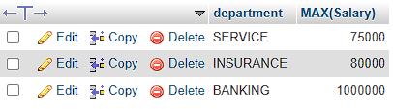

( H ) answer = SELECT FM,incentiv_AMT from employe A inner JOIN incintiv B on A.EM_id = B.EM_REF_id and incentiv_AMT > 3000 ;

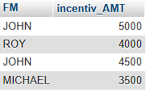

( I ) answer = SELECT * FROM employe order by salary desc limit 1,1;

( J ) answer = SELECT FM,incentiv_AMT FROM incintiv A left JOIN employe B on A.EM_REF_id=B.EM_id and incentiv_AMT

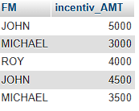

( K ) answer = CREATE VIEW employe_Fm_LM_salary AS SELECT FM,LM,Salary FROM employe;

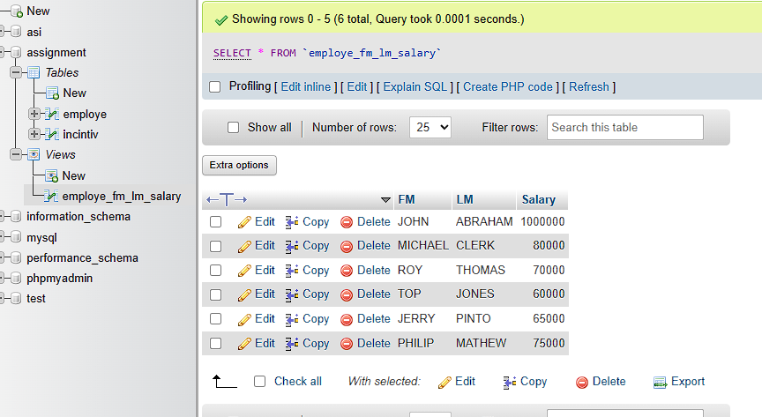

( L ) answer = SELECT department , max(Salary) FROM employe GROUP BY department ORDER BY Salary;

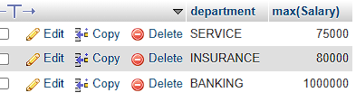

( M ) answer =

CREATE TABLE SALES_PERSON(

SNO int PRIMARY key AUTO_INCREMENT,

SNAME varchar(50),

CITY varchar(50),

COMM float

);

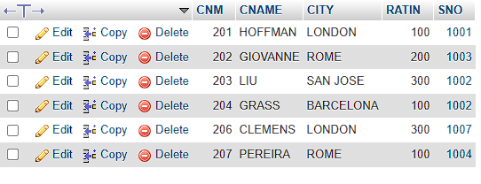

CREATE TABLE CUSTOMER(

CNM int PRIMARY key AUTO_INCREMENT,

CNAME varchar(50),

CITY varchar(50),

RATIN int,

SNO int,

FOREIGN KEY(SNO) REFERENCES SALES_PERSON (SNO)

)

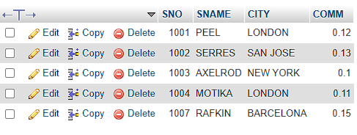

create TABLE CustomerOrder(

ONM int PRIMARY key AUTO_INCREMENT,

AMT float ,

ODE TIMESTAMP DEFAULT CURRENT_TIMESTAMP,

CNM int,

SNO int,

FOREIGN KEY (CNM) REFERENCES customer (CNM),

FOREIGN KEY (SNO) REFERENCES SALES_PERSON (SNO)

)

INSERT INTO `sales_person` (`SNO`, `SNAME`, `CITY`, `COMM`) VALUES ('1001', 'PEEL', 'LONDON', '0.12');

INSERT INTO `sales_person` (`SNO`, `SNAME`, `CITY`, `COMM`) VALUES ('1002', 'SERRES','SAN JOSE', '0.13');

INSERT INTO `sales_person` (`SNO`, `SNAME`, `CITY`, `COMM`) VALUES ('1003', 'AXELROD', 'NEW YORK', '0.1');

INSERT INTO `sales_person` (`SNO`, `SNAME`, `CITY`, `COMM`) VALUES ('1004', 'MOTIKA', 'LONDON', '0.11');

INSERT INTO `sales_person` (`SNO`, `SNAME`, `CITY`, `COMM`) VALUES ('1007', 'RAFKIN', 'BARCELONA', '0.15');

INSERT INTO customer(CNM,CNAME,CITY,RATIN) VALUES(201,"HOFFMAN","LONDON",100),(202,"GIOVANNE","ROME",200),(203,"LIU","SAN JOSE",300),

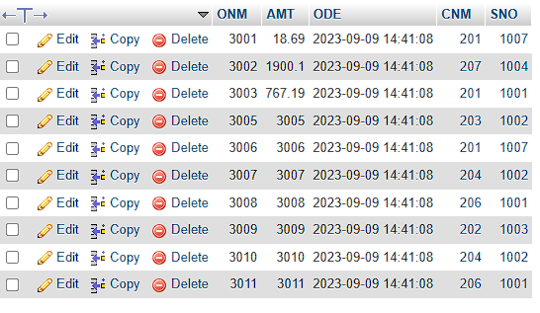

(204,"GRASS","BARCELONA",100),(206,"CLEMENS","LONDON",300),(207,"PEREIRA","ROME","100")

UPDATE `customer` SET `SNO` = '1001' WHERE `customer`.`CNM` = 201;

UPDATE `customer` SET `SNO` = '1003' WHERE `customer`.`CNM` = 202;

UPDATE `customer` SET `SNO` = '1002' WHERE `customer`.`CNM` = 203;

UPDATE `customer` SET `SNO` = '1002' WHERE `customer`.`CNM` = 204;

UPDATE `customer` SET `SNO` = '1007' WHERE `customer`.`CNM` = 206;

UPDATE `customer` SET `SNO` = '1004' WHERE `customer`.`CNM` = 207;

INSERT INTO customerorder(AMT) VALUES(18.69),(1900.1),(767.19),(3005),(3006),(3007),(3008),(3009),(3010),(3011)

( A ) Answer = SELECT AMT from customerorder WHERE AMT > 1000;

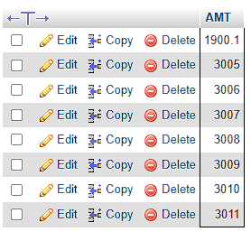

( B ) Answer = SELECT SNAME, CITY,COMM FROM sales_person WHERE CITY = "LONDON" and COMM > 0.10;

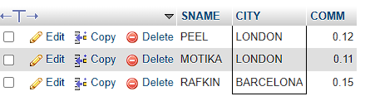

( C ) Answer = SELECT SNAME, CITY,COMM FROM sales_person WHERE CITY = "BARCELONA" OR CITY = "LONDON";

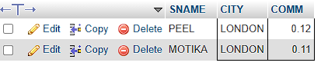

( D ) Answer = SELECT * FROM sales_person WHERE COMM > 0.10 and COMM < 0.12;

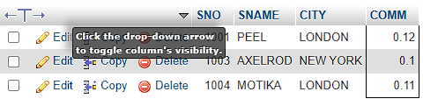

( E ) Answer = SELECT * FROM customer WHERE CITY IS NULL;



( F ) Answer = SELECT * FROM customerorder WHERE DATE(ODE) BETWEEN "1994-10-03" and "1994-10-04"

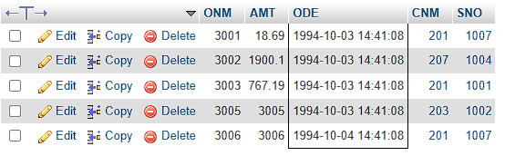

( G ) Answer = SELECT * from sales_person A right join customer B on A.SNO = B.SNO WHERE SNAME = "PEEL" OR SNAME = "MOTIKA"

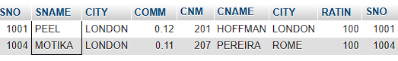

( H ) Answer = SELECT CNAME from customer where CNAME BETWEEN "A%" and "Z%"

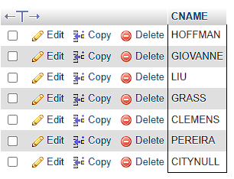

( I ) Answer = SELECT * FROM customer WHERE RATIN > 100 OR CITY = "ROME"

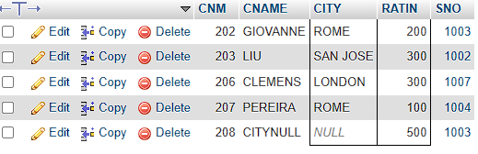

( J ) Answer = SELECT * from customerorder WHERE AMT > 0 and AMT IS NOT NULL;

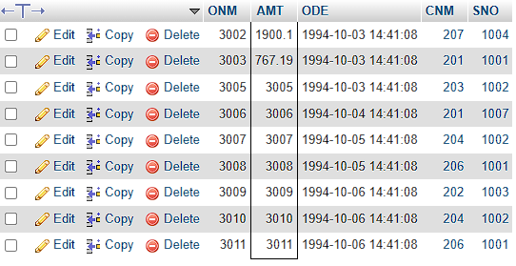

( K ) Answer = SELECT COUNT(DISTINCT SNAME) FROM sales_person;

